**Excess of fertilizers affects floral traits and reduces fruit production of pollinator-dependent crops**

**Luiz Henrique Lino de Oliveira 1,2, Luísa Carvalheiro 1,2**

1Programa de Pós-Graduação em Ecologia e Evolução, Depto. de Ecologia, Universidade Federal de Goiás, Goiânia, GO, Brasil.

2Laboratório de Ecologia de Comunidades, Universidade Federal de Goiás, Av. Esperança, s/n - Chácaras de Recreio Samambaia, Goiânia - GO, 74690-900 Brasil

Corresponding author: lhlino.oliveira@gmail.com

This chapter was formatted following the rules of XXXXX.

**Abstract (310 words)**

To meet the increasing food demand and associated changes in consumption patterns, the use of fertilizers in agriculture has greatly increased. While, for most crops, fertilizers are essential to improve cropland productivity, many farmers apply more nitrogen than recommended for their crops, hoping to increase production and profit. Such excess of nutrients leads to environmental eutrophication with well-known negative impacts on biodiversity. Yet, it may also lead to negative impacts to the crop production itself via effects on the quality of vegetative and reproductive tissues that affect interaction patterns between the plant and beneficial insects, such as pollinators. As most crops are pollinator-dependent, identifying thresholds above which negative impacts on floral resources and pollinators are more likely to occur is essential to establish more sustainable agricultural management protocols that aim to increase production via ecological intensification. Here, we summarize the results from 96 studies covering 60 plant species that tested the effects of nitrogen input on floral resources and fruit production. We show that benefits of increasing nitrogen inputs for flower production are in majority less accentuated above the recommended N dosages for the crop, negatively affecting flower traits that are important to attract pollinators, such as flower size and weight (this last being related with size but also with amount of pollen and nectar). For fruit production the initial benefits of N input even turn into negative effects, these being more accentuated in plants that have higher dependence on pollinators. These effects were similar across different climatic regions. Overall, the results of this study suggest that excessive input of N in crops has negative effects on production that are driven by changes in pollinator activity. As fertilizer costs are high, these results also suggest that investing in more environmentally friendly practices (i.e., maintaining fertilization within, or even slightly below, the recommended levels), can contribute to crop productivity and improve farmers' revenue.

**Keywords**: agricultural intensification, crop fertilization, nitrogen enrichment, flowering, fructification

**Introduction**

Nitrogen (N) is one of the most important macronutrients for plants to thrive and fundamental for photosynthesis since it has an important role in plant vegetative growth, and flower production, as well as flower quality and phenology (Evert; Eichhorn; Raven, 2012 p.685, Taiz et al. 2015). Despite being abundant in atmosphere (N2), it is a limited resource for all living beings since it needs to be converted in reactive forms such as nitrate (NO3-) or ammonium (NH4+) (Amâncio and Stulen, 2005). Consequently, many plants species invest in strategies to effectively acquire the necessary amounts of N from soils where they naturally occur (Lopez-Bucio et al 2003, Miller and Cramer 2005, van der Heijden et al 2008, Kiba and Anne., 2016). For crop species, which are frequently planted in degraded and impoverished soils, fertilization practices are required to improve production levels (Ameen and Raza 2017). For the vast majority of crop species, research studies by government and private companies have been done to identify the adequate dosages of N and other nutrients for each specific type of agricultural species (e.g., Embrapa). These optimal dosages reflect a point above which benefits are not sufficient to compensate investment in fertilizer and may be related to other inputs required to achieve optimal yields such as water, pest management and pollinators (Bommarco et al. 2013). Yet, many farmers end up over-applying fertilizer as they consider that the risks (for their production) associated with applying too little nitrogen are greater than those of applying nutrients in excess (Miller&Cramer, 2004). Consequently, farmers are frequently more than doubling N applications (e.g., Sheriff., 2005; Ramos et al., 2018; Houser., 2022).

The excess of fertilizer in the soil (driven by agriculture and industrial sources) ends up leaching to terrestrial and aquatic adjacent environments having substantial negative impacts on biodiversity e.g., eutrophication (Martinelli., 2007; Tilman; Reich; Isbell., 2015; Farrer and Suding., 2016; Midolo et al., 2018). The impacts of environmental eutrophication on terrestrial ecosystems are likely to be greater in areas where plants are well adapted to soils that has naturally low N availability such as the Brazilian savannas (e.g., Bustamante et al., 2012). Yet, the excess of fertilizer in the soil can be partially uptake by crop plants causing negative effects on the crop itself. For example, nitrogen levels can affect flower morphology and chemistry, influencing pollinators interact with the plants (Taiz et al., 2015, Swetha et al., 2018; David et al 2019) and, consequently, fruit production. It is estimated that more than 70% of the crops are dependent on pollinators to some extent (Klein et al. 2007; IBPES 2016) estimations of the economic value of pollinators being expressive (e.g., in 2009 the annual global value was estimated to be 235-577 billion US$, Gallai et al. 2009). Detailed evaluations of perceived benefits and negative effects on floral resources and crop production driven by fertilization are hence essential to promote more sustainable farming practices, optimizing productivity while improving the efficiency of N utilization and minimizing the negative impacts on natural ecosystems. Moreover, improving our understanding on how variable are such effects across plant species and climatic regions is essential to better predict impacts of global changes and to motivate farmers to avoid such harmful practices and develop strategies of sustainable development of agriculture.

Here, we synthesize information from experiments that test the effect of nitrogen addition on flowering and fruit set to understand if the extent of positive effects on fruit set depends on pollination dependence of the plant species and if such effects (in flower investment and fructification) vary across regions with different climatic conditions. Specifically, since the cost of reproductive structures is greater than of vegetative growth (Reekie and Avila-Sakar., 2005), if a plant is under N deficiency, N addition is expected to have positive impact on floral resources which will, in turn, lead to positive effects to fruit production (expectation 1). On the other hand, if such N supply is above plant requirements, benefits to plant may cease (Kakon et al., 2015) and hence investment in flowering will no longer be detected or will be less accentuated (expectation 2). Moreover, such excessive levels of N may reduce the perceived quality of floral resources to floral visitors, affecting interactions (David; Storkey; Stevens., 2019), and potentially reducing pollinator efficiency and fruit production (e.g. Ramos et al., 2018) . Therefore, we expect that adding N above recommended dosages will lead to negative impacts on pollination and fruit production (expectation 3). Finally, as climate regulates nutrient uptake by plants (Anderson, 2015), absorption of N in the form of nitrate is optimized under warm temperatures, and absorption N in form of ammonia is enhanced under cooler temperatures (Warren, 2009). Consequently, we expect that the response of plants to changes in soil N availability also be mediated by climate (expectation 4).

**Methodology**

*Systematic review*

We did a systematic review of the existent scientific literature (published between 1945 until January 2023) using two search platforms: Web of Science and Google Scholar.

To make the search as comprehensive as possible, the following keywords link by Boolean operators “AND” and “OR” were used as search terms for flower characteristics: ("nitrogen" OR “fertilizer”) AND ("flower production" OR "flower number" OR "inflorescence number" OR "inflorescence production" OR "pollen production” OR "nectar production" OR "pollen quality” OR "nectar quality" OR "flower size"). For production"soil nitrogen" AND ("fruit production" OR “yield” OR "fruit per plant” OR “fruit weight” OR “seed production” OR “grains per pod” OR "seed weight"). Only publications with full text accessible and concerning effects of changes in soil nitrogen in plant, flower or production will be considered. To be included in our analyses, these publications have to meet the following criteria: (1) the study used an experimental approach and compared one of the selected metrics described above under at least two different levels of nitrogen availability; (2) reports the mean; (3) reports replicate sizes; (4) evaluated plant species for which information on nitrogen recommended dosage for the study region were currently available (i.e., within the article, reports, specialized sites).

All references cited within the selected publications were examined to check if they met the criteria to be added to our database.

*Selected metrics*

To evaluate the effects of climate and the impacts and varying levels of nitrogen input on flowers (abundance and quality) we focused on specific metrics that are known to be influenced to some degree by nitrogen additions (Leghari et al. 2016) and influence flower attractiveness to pollinators (Carvalheiro et al. 2014; Reverté et al. 2016; Jones and Jones 2001) and for which there was a reasonable number of studies: number of flowers per plant individual, flower size, flower weight (that is affected by flower size and nectar and pollen production). To evaluate the impacts of varying levels of nitrogen on fructification, we used as metrics the number of seeds or fruits and the weight of individual fruit or seed, which are important indicators of yield.

*Nitrogen dosage information*

For each selected study site, we extracted information on local temperature and nitrogen dosage for each treatment used. Level information on the recommended dosage of nitrogen (RD) for sowing the plant species used was extracted from the literature by country, region or soil similarity. Then, for each treatment within the study, we assessed how the level of N input differed from the recommended level for that specific plant species, by calculating the relative difference between the N dosage of the treatment and the recommended N dosage (eq 1). Values below 1 indicate that the N input is below the recommended dosage. Values above 1 indicate that N input is above the recommended dosage.

$\frac{N dosage kg.ha (treatment)}{ N kg.ha recommended}$*eq. 1*

Within each study, for each plant used in the experiment we extracted the values of each of the target response variable used in that specific study and treatment to which it was subjected. Whenever individual information was not provided per plant, we extracted mean value per treatment and registered the sampling effort. However, if no study report variance values were found, such information will be considered as a single data point in our analyses. As different studies used different methodologies and metrics, to standardize the response variable (metrics of vegetative growth, flower abundance and quality, or fruit production), for each study, we calculated the effect size as the relative difference between the value obtained for a specific treatment and that obtained in the lowest level of N input used in that study (eq.2). We used the value obtained in the lowest N input level rather than in the recommended level because in many studies no treatment applied the exact value of the recommended dosage.

$\frac{value of N inputs}{value of N lowest input}$*eq. 2*

*Climatic data*

For each study site, we used the coordinates to extract information on annual mean temperature (AMT) with the spatial resolution of 10 min (~340 km2) of the study region from WorldClim.

*Pollination dependence*

To estimate the values of pollination dependence for each cultivar we used the values in the study of Siopa and collaborators (2023) using the mean and maximum estimated values. For crops not listed in Siopa et al (2023) we complemented with information from FAO (2018) and the work of Klein and collaborators (2020).

*Statistical analyses*

To test how changes in N input (eq 1) affect each type of response variable (reproductive investment and fruit production, eq 2), we used general linear mixed models (GLMM) with study ID, plant species, number of replicates and type of metric as random effect using lme4 package (Bates et al. 2015). To check if the effect of N input varied between metrics and across climatic regions, environmental temperature and type of metric were also included as fixed term, as well as the two-way and three-way interactions between variables. For fruiting models, pollinator dependence level of the plant species was also included, as well as the two-way and three-way interactions with the other fixed factors. This variable allowed to test if the effect of N input was more accentuated for species with higher pollinator dependence (expectation 3).

To test if the direction of the effect of N input changes after certain threshold values, we compared models assuming linear growth (i.e., no change in effect, continuous positive effect throughout N input gradient), logarithmic growth (positive effect strength weakens as N input values increase, tending to a null effect), and a quadratic relationship (positive effect followed by negative effect). The three full models were compared using Akaike Information Criterion (AIC). After selecting the best transformation for N input, a model selection was applied to the full model to check if N input effects varied across metrics, pollinator dependence level and climate. Then, once the full model was defined, we generate a full sub-model from the full model using dredge function and the recommended dosage as the intercept (Bartón, 2009).

**RESULTS**

A total of 96 independent studies from 31 countries were selected after the systematic review (Fig 1a, Table S1). Together, these led to a total of 60 plant species studied, of which 32 were species used for gardening 28 and were agricultural crops with information of flowering and fruiting. These species cover a range of pollinator dependence from 0 to 100% dependent (see Fig 1a red dots, Table S2). Across all plant species, we had 1081 values for flowering, and 484 values for fruiting.

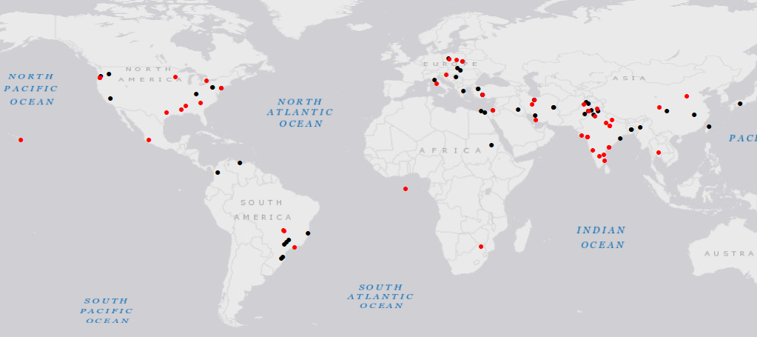

Figure 1a. Location of the studies selected after the systematic review. Black dots represent studies that has only flowering information. Red dots represent studies that has both flowering and fruiting values.

*Flowering metrics*

Our results show that increasing the levels of N, affects reproductive plant tissues (Fig 2,). As expected, a beneficial effect of increasing N input was detected even at up to the recommended dosage (expectation 1). Yet, the relation between N input and the different flowering metrics was quadratic with positive effects turning into negative effects after a given point. Indeed, the quadratic model was selected over a linear or logarithmic model in all cases, furthermore, in the model selection using dredge function, it was selected the second-best model since the variables that was not showed in the first model better described the effects in flowering (see Table 1). The strength of such initial positive effects as well as the threshold point at which effects begin to decrease over applications slightly varied between flowering metrics (expectation 2). The initial positive effect was more marked for flower abundance than for flower quality metrics (size and weight). In all metrics positive effects were still detected when dosages of N were 50% above the recommended, but such additional input only improved flowering in less than 10% for abundance and weight and 5% in size. In addition, the effect of N input was independent of environmental temperature in the study region (Table 1).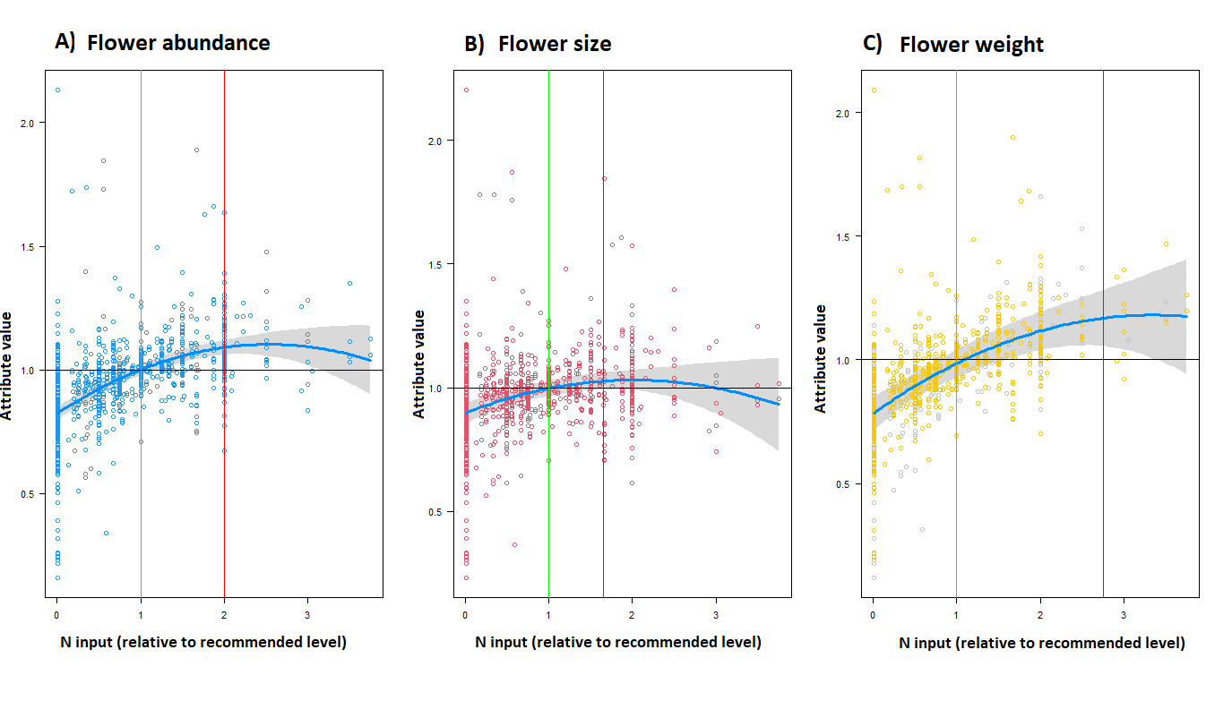

Figure 2. Effect of changes of soil nitrogen availability on flowering on each of the specific metrics (A-C) N input levels presented are relative to the recommended dosage, ‘1’ meaning that the value added was equal to the recommended dosage. Change in attribute values presented was calculated relative to the value obtained in the recommended N input level for each study. Green vertical line highlights where N input is equal to the recommended levels, values below 1 represent dosages below the recommended level, and values above 1 represent dosages N additions above recommended dosages. Red lines represent the point at which positive effects are no longer detected. Black horizontal line represents the values that are equal to that of the recommended N input level used in a given study.

*Effect of N on fructification metrics through pollination*

The results show that the extent of positive effects on fruit set depends on pollination dependence, i.e., increasing the levels of N, affects fructification through pollination (Fig 3). It was detected a negative effect of increasing N input up to the RD (>100%) for plants that is PD (expectation 3) in which impact fructification, especially those who has highly PD (Figure S1). The relation between N input and the different pollination dependence was quadratic with positive effects turning into negative effects after a given point. The quadratic model was selected over a linear or logarithmic model in all cases, furthermore, in the model selection using dredge function, it was selected the second-best model since the variables that was not showed in the first model better described the effects in crop production (see Table 1). The strength of such initial positive effects remains slightly the same in all situations below RD, but the effects varied over applications after the threshold point. As expected, the positive effect after the threshold was more marked for plants that has no pollination dependent with the negative impact of N additions being more accentuated as the dependence level increases. Just as for flowering, the effect of N input and pollination dependence was 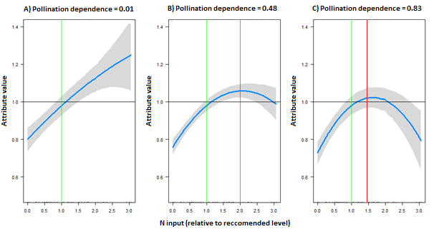independent of environmental temperature in the study region (Table 1)

Figure 3. Effect of changes of soil nitrogen availability on fruit set mediated by pollination: effect on crop production when pollination is at 0.01 (A) effect on crop production when pollination is at 0.48 (B) effect on crop production when pollination is at 0.83 (C). N input levels presented are relative to the recommended dosage, ‘1’ meaning that the value added was equal to the recommended dosage. Change in attribute values presented was calculated relative to the value obtained in the recommended N input level for each study. Green vertical line highlights where N input is equal to the recommended levels, values below 1 represent dosages below the recommended level, and values above 1 represent dosages N additions above recommended dosages. Red lines represent the point at which positive effects are no longer detected. Black horizontal line represents the values that are equal to that of the recommended N input level used in a given study.

**DISCUSSION**

*Is nitrogen good for flowering?*

Our findings indicate that when starting in low dosage (LD), N, in fact can enhance flowering (see also Burkle and Irwin 2009a; 2009b) (Fig 2). These positives responses in flowering in low environmental conditions i.e., nitrogen deficiency (Tanaka, 1991) is probably partially being induced in response to plant stress (Zhang, 2021; Sanagi et al. 2021). However, as each plant can respond differently even with genetical conditions similarly when exposed to the same stress (Kolar, 2008; Shiwamaka, 2012; Takeno 2016) and the knowledge gap about flowering in crop species, more studies are necessary to understand the role of nitrogen in flowering crops. At RD, N increases can dilute the trade-off in the plant vegetative/reproduction (discussed by Reekie and Avila-Sakar 2005), with both metrics increasing under N additions. After the turning point, the reduction (flower abundance) and even negative effect (size) is more accentuated probably due to the known impacts of plant Intoxication by N excess that influence its physiology and growth (Goyal and Huffaker. 1984; Bobinik et al. 2010). Therefore, just as for vegetative, N can possibly reach toxic levels in plant reproductive tissues impacting the plant negatively, as discussed by Goyal and Huffaker (1984) and Bobinik et al. (2010). We can conclude that these effects might justify the changes in flowering. However, understanding how N influences flowering tissues is still dearth and more data is certainly needed.

*The role of nitrogen effect on flowering metrics*

The pattern observed in the negative impact on N excess in flower size and flower weight (Fig 3) could suggest that the excess of N reduces flower size by shrinking it (see results of Ahmad 2004; Ruamrungsri et al. 2021), with the negative effects possibly being intertwined with the content of nectar and pollen production in which impact directly flower weight and content (see Burkle and Irwin 2010, Atasay et al. 2013). To pollinators, flower size is viewed as an indicator of potential reward with bigger flower being visited by richer assemblage of floral visitors (Delgado, 2023). Therefore, a decrease in flower size and consequently in flower resources could reduce the flower attractiveness or even morphologically prevent interactions with pollinators.

*The effect on flower abundance*

Previous studies have shown that low levels of N input can stimulate flowers production (Burkle and Irwin 2009a; 2009b, Bevan et al. 2021, Vaudo, 2022), but our findings show that such benefits of quantity and quality are only likely when the levels of N are below to RD (Fig 3). Therefore, when in N oversupply the gain to surpass the RD +50% is either too low of none. Even more, the negatives effects after the turning point that reduce flower abundance could be due the N intoxication that induce the plant to suffer from inflorescence necrosis (Gu et al. 1996, Saloner and Berstein 2022), floral abortion or inhibit flower production (Hampton et al. 2012). The detected effects on flower quantity and quality might also affect flower visitation patterns. Studies indicate that the interaction of plant–pollination is sensitive to flower density, and a reduction in flower size and consequently flowering display may be related to the decrease in plant attractiveness (Essemberg 2013). Depending on the dosage, N also might be deadly for some types of pollinators by decreasing the survival of insect larvae (Ceulemans et al., 2017; Kurze et al. 2018). Therefore, since approximately 75% of cultivars depend somehow on pollination (IPBES 2016), and in this study, ~87% of cultivars had some benefit from on pollination, the increase in flower tissues and attractiveness to pollinators might become a new alternative to increase productiveness, however, further studies about how N can affect pollination community and production still needed.

*Effects of nutrient enrichment on pollination dependence*

There are studies where N mediated changes in flower quality can affect pollinator visitation and pollination effectivity (Ceulemans et al. 2017). As expected, our findings suggest that N influenced pollination dependence (PD) (Fig 4). To plants that has others sources of pollination despite pollinators, an increase in fructification attributes were found even in higher N dosages. However, for plants that are benefited with pollinators, when below RD, PD is enhanced by N, but, after the RD, the gain in pollination is too little (~5%) and even more, when N are in excess (RD up to 50%) no beneficial effect is found with negative effects occurring as N addictions progress. In fact, for plants that are PD Tamburini; Lami; Marini (2017) found similar results with sunflower showing that pollination benefits to yield ~25% at intermediate levels of N when compared with pollinator exclusion. Marini et al., (2015) also found that pollination benefits are increased in at low N inputs in oilseed rape, while under high N availability plants compensate the lack of pollinators by increasing the number of flowers and fruits, a well effect observed in our data. In particular, we found that LD or RD along with pollination can potentially compensate for higher N applications in plants PD. Therefore, our results support ecological intensification (Pywell et al., 2015) as a safer strategy for sustainable management of crop-systems and maximized yield.

*Effects of nutrient enrichment on fruit and seed production*

Similar effects of excess N were found for fruit production and flowering (Fig. 2 and 5), these effects are expected due to the excessive application of N that might cause blossoms to drop, floral abort or fewer flowers produced that decrease fruit production. These negative effects occur in response to N toxicity, leading some plants to invest more in vegetative biomass to increase photosynthetic capacity rather than reproduction (Hampton et al., 2012). Even more, high N inputs can increase the plant's susceptibility to contracting diseases that also lower fruit production (See O´neal et al. 2015). The intensity of flowering indeed regulates fruit/seed production. The increase in investment in flower number above RD (Fig 3) being similar to that detected for fruit yield (Fig 3), might indicate that fruit number mostly depends on flower number. However, even though N had little positive effect on seed weight (FIG 3), for fruit weight, the threshold points at which negative impacts start being noticeable occurs much sooner, suggesting that even if fruits keep being produced above RD, their quality drops. However, more studies are needed to elucidate if this drops in quality results from the plant egg's malformation by N excess or inadequate pollination. Also, imbalances between the excess of N and other nutrients (e.g., P - K) might result in inappropriate relations in the plant, with some nutrients limiting the efficiency of others (see liebigs laws REF), causing nutrient deficiency and resulting in low fruit production (Meneghetti et al. 2010; Morris and Blackwood, 2007). Another possible reason that individual fruit weight threshold point is reached sooner than fruit yield is that if fruit production is too high, plants may not have enough resources to maintain fruit quality. Indeed, for certain crops, farmers prune flowers to avoid excessive fruit production and ensure larger fruits (Jannoier and Lauri 2006). Indeed, when a disproportional number of flowers is produced and pollinated, it causes the plant to proportionally allocate less resources to these flowers, making the fruits grow smaller (Stover 2000). Our data suggest that the successive increase in high N does not translate into higher production (ca 2%~4% for exceeding 50% of RD) and potentially diminishes farmers' profits and increases the cost for the producer and final consumer. Indeed, Locascio et al. (1984) stated that excessive dosages of N can dampen the yields reducing the quality of the product and their market value (e.g., undesirable flavor and bad odor). Also, there could be an advantage for family farmers that use low dosages of N since the increases above 50% to 100% of RD represent ca 3%~5% of the increase in fructification metrics. Therefore, once N additions represent a great cost in modern agriculture, the addition below RD might translate into a reduction of 50% of the cost used to buy N without expressively losing production.

*Concluding remarks*

Environmental eutrophication is a well-known negative impact on the environment, and one of its main drivers is the misuse of crop fertilizers. Our findings show that the negative effects of applying nitrogen above recommended dosages are more significant for fruit and pollination. This difference might be associated with the N Toxicity and changes in flowering, with the mechanism that explains this difference likely also related to changes in plant/flower chemistry and, consequently, interactions with pollinators. However, further studies about the interactions between highly N addition and pollination community behavior are needed. As we demonstrate here, the increase in fruit/seed production caused by almost doubling the N input is small (less than 5%) and associated with the risk of diminishing the product market value and reduce in pollinator community. Unfortunately, some countries, such as Brazil, have no specified legislation regulating the practice of nutrient oversupply, and many farmers are unaware of the negative impacts of such practices on their production. Detailed economic evaluations of costs and benefits associated with changes in fertilizer levels would be needed, but our results strongly suggest that benefits are far less than how much the farmer will spend on nutrient supply.

The investment and success of these adaptations may vary with environmental conditions, such as soil nutrient supply (Lopez-Bucio et al 2003, Hodge et al. 2004), soil age (Lambers et al. 2007), and climate (Brouder and Volenec 2008, St Clair et al 2010). For example, air temperature can affect the N uptake, and hence the growth, of certain plant species (Warren, 2009). For example, some species are more susceptible to absorb N in form of nitrate under warm temperatures, whereas others that absorb N in form of ammonia are better suited to absorb it under cooler temperatures (Warren, 2009). Consequently, the response of plants to changes in soil nutrient availability can greatly vary across plants species and regions.

Human activities are increasing the availability of several nutrients (especially nitrogen and phosphorous) in soils and water to such an extent that the impacts are currently considered irreversible (Steffen et al 2015 ). One of the main sources of this excessive nitrogen is the inadequate use of fertilizers in agriculture. While fertilization with N and other nutrients is essential for farming

Table 1. Comparison of model fit of models assuming different relationships between N input and response metric (linear, logarithmic, quadratic via square root transformation of N input, quadratic via 2-way polynomial), Effect of increased nitrogen availability on flowering and fructification. Data were analyzed with general linear mixed models (GLMM) including N. A Model selection was run for trait specific attributes (individual attributes as a fixed effect). P- value of ANOVA for the selected models were always significant (p<0.001). AIC = Akaike information criterion df= degrees of freedom.

|  |  |  |  |  |
| --- | --- | --- | --- | --- |
| **Attribute** | **Model** | **df** | **AIC** | **ΔAIC** |
| **Flowering** | Linear | 14 | -732.3 | **46.9** |
| Quadratic | 20 | -779.2 | **0.0** |
| Sqrt | 14 | -773.8 | **5.4** |
| logaritic | **14** | -740.3 | **38.9** |
| **Fruiting PD** | Linear | 26 | -496.8 | **103.3** |
| Quadratic | 38 | -600.1 | **0.0** |
| Sqrt | 26 | -538.5 | **61.6** |
| logaritic | **26** | -445.2 | **154.9** |

Table 2. Effect on N input, fructification metrics (frm), flowering metrics (fm), mean pollinator dependence (PD_mean) and environmental temperature (Temp) on flowering and fruiting. Table presents the best-fitted models obtained for each response variable. N input transformation used was quadratic in all cases (most adequate, see Table 1). The full model included all variables and their 2-way and 3-way interactions. The best four models for flowering and crop fructification are presented. For each term selected in a model, the P-values within cells were obtained with a log-likelihood ratio tests (p>0.001) between a model with a without the term. (-) indicates that the term was not included in the model. (+) indicates that the term was included in the model

|  |  |  |  |  |  |  |  |  |  |  |  |
| --- | --- | --- | --- | --- | --- | --- | --- | --- | --- | --- | --- |
| **Crops** | **Models** | **poly (dif.rec,2)** | **frm** | **Temp** | **poly (dif.rec,2)*fm** | **PD_mean** | **PD_mean*poly(dif.rec,2)** | **PD_mean*fm** | **AIC** | **ΔAIC** | **df** |
| Model 1 | (+) | (-) | (-) | (-) | -0.04 | (+) | (-) | -689.8 | 0 | 8 |
| Model 2 | (+) | (+) | (-) | (+) | -0.09 | (+) | (+) | -687.7 | 2.05 | 20 |
| Model 3 | (+) | (-) | (-) | (-) | - | (-) | (-) | -687.2 | 2.52 | 5 |
| Model 4 | (+) | (+) | (-) | (+) | -0.04 | (+) | (-) | -684.5 | 5.28 | 14 |
|  | **Models** | **poly(dif.rec,2)** | **fm** | **Temp** | **poly (dif.rec,2)*fm** |  |  |  | **AIC** | **ΔAIC** | **df** |
| **Flowers** | Model 1 | (+) | (-) | (-) | (-) | - | - | - | -842.2 | 0 | 5 |
| Model 2 | (+) | (+) | (-) | (+) | - | - | - | -837.9 | 4.28 | 11 |
| Model 3 | (+) | (+) | -0.001 | (-) | - | - | - | -829.6 | 12.59 | 6 |
| Model 4 | (+) | (+) | (-) | (+) | - | - | - | -826.7 | 15.50 | 7 |

**References – in construction**

ANDERSON, J T. Plant fitness in a rapidly changing world. **New Phytologist**, v. 210, n. 1, p. 81-87, 2016.

Ameen A, Raza S. 2017 Green Revolution: A Review. Int. J. Adv. Sci. 3, 129–137. 1033 (doi:10.7439/ijasr.v3i12.4410)

Bates D, Mächler M, Bolker B, Walker S. 2015 Fitting Linear Mixed-Effects Models Using 1043 lme4. J. Stat. Softw 67, 1–48. (doi:10.18637/jss.v067.i01)

BROUDER, Sylvie M.; VOLENEC, Jeffrey J. Impact of climate change on crop nutrient and water use efficiencies. **Physiologia Plantarum**, v. 133, n. 4, p. 705-724, 2008.

Bustamante MMC, Nardoto GB, Pinto AS, Resende JCF, Takahashi FSC, Vieira LCG. 2012 1073 Potential impacts of climate change on biogeochemical functioning of Cerrado ecosystems. 1074 Braz. J. Biol. 72, 655–671. (doi:10.1590/S1519-69842012000400005)

CARVALHEIRO, Luísa Gigante et al. The potential for indirect effects between co‐flowering plants via shared pollinators depends on resource abundance, accessibility and relatedness. **Ecology letters**, v. 17, n. 11, p. 1389-1399, 2014.

David, T.I., Storkey, J. & Stevens, C.J. Understanding how changing soil nitrogen affects plant–pollinator interactions. *Arthropod-Plant Interactions* **13**, 671–684 (2019). <https://doi.org/10.1007/s11829-019-09714-y>

Falster DS, Westoby M. 2003 Plant height and evolutionary games. Trends in Eco. Evol. 18, 1094 337–343. (doi:10.1016/S0169-5347(03)00061-2)

Farrer EC, Suding KN. 2016 Teasing apart plant community responses to N enrichment: the roles of resource limitation, competition and soil microbes. Ecol Lett 19, 1287–1296. (doi:10.1111/ele.12665)

Gallai N, Salles J-M, Settele J, Vaissière BE. 2009 Economic valuation of the vulnerability of world agriculture confronted with pollinator decline. Ecol. Econ. 68, 810–821. (doi:10.1016/j.ecolecon.2008.06.014)

Houser M. 2022 Farmer Motivations for Excess Nitrogen Use in the U.S. Corn Belt. CSCEE 6, 1688823. (doi:10.1525/cse.2022.1688823)

IPBES. 2016 Summary for policymakers of the assessment report of the Intergovernmental Science-Policy Platform on Biodiversity and Ecosystem Services on pollinators, pollination and food production. Germany.

Jones GD, Jones SD. 2001 The uses of pollen and its implication for Entomology. Neotrop. 1133 entomol. 30, 314–349. (doi:10.1590/S1519-566X2001000300001)

Kakon SS, Bhuiya MSU, Hossain SMA, Sultana N. 2015 Flowering Behaviour and Seed Yield of French Bean as Affected by Variety. IJASBT 3, 483–489. (doi:10.3126/ijasbt.v3i3.12566)

Klein A-M, Vaissière BE, Cane JH, Steffan-Dewenter I, Cunningham SA, Kremen C, Tscharntke T. 2007 Importance of pollinators in changing landscapes for world crops. Proc. Royal Soc. B P ROY SOC B-BIOL SCI 274, 303–313. (doi:10.1098/rspb.2006.3721)

Kiba T, Krapp A. 2016 Plant Nitrogen Acquisition Under Low Availability: Regulation of 1139 Uptake and Root Architecture. Plant Cell Physiol 57, 707–714. (doi:10.1093/pcp/pcw052)

LAMBERS, Hans et al. Plant nutrient-acquisition strategies change with soil age. **Trends in ecology & evolution**, v. 23, n. 2, p. 95-103, 2008.

Leghari SJ, Wahocho N, Laghari G, Laghari A, Bhabhan G, HussainTalpur K, Ahmed T, Lashari A. 2016 Role of Nitrogen for Plant Growth and Development: A review.

LÓPEZ-BUCIO, José; CRUZ-RAMIREZ, Alfredo; HERRERA-ESTRELLA, Luis. The role of nutrient availability in regulating root architecture. **Current opinion in plant biology**, v. 6, n. 3, p. 280-287,

2003.

MILLER, A. J.; CRAMER, M. D. Root nitrogen acquisition and assimilation. **Plant and soil**, v. 274, p. 1-36, 2005.

Midolo G, Alkemade R, Schipper AM, Benítez-López A, Perring MP, De Vries W. 2019 Impacts of nitrogen addition on plant species richness and abundance: A global meta-analysis. Glob. Ecol. and Biog. 28, 398–413. (doi:10.1111/geb.12856)

OLLERTON, Jeff; WINFREE, Rachael; TARRANT, Sam. How many flowering plants are pollinated by animals? **Oikos**, v. 120, n. 3, p. 321-326, 2011.

Reverté S, Retana J, Gómez JM, Bosch J. 2016 Pollinators show flower colour preferences but 1199 flowers with similar colours do not attract similar pollinators. Annals of Botany 118, 249–257. 1200 (doi:10.1093/aob/mcw103)

Ramos D de L, Bustamante MMC, Silva FD da S, Carvalheiro LG. 2018 Crop fertilization affects pollination service provision – Common bean as a case study. PLOS ONE 13, e0204460. (doi:10.1371/journal.pone.0204460)

Reekie E, Avila Sakar G. 2005 The Shape of the Trade-off Function between Reproduction and Growth. In Rep. Alloc. in Plants, pp. 189–214. (doi:10.1016/B978-012088386-8/50007-7)

Steffen, W., Richardson, K., Rockstrom, J., Cornell, S.E., Fetzer, I., Bennett, E.M., et al. (2015). Planetary boundaries: Guiding human development on a changing planet. Science (80-. )., 347, 737–747

Martinelli LA. 2007 Os caminhos do nitrogênio do fertilizante ao poluente. Inf. Agro. 118,

Swetha J, Suseela T, Dorajeerao AVD, Suneetha DS, Sujatha RV. 2018 Effect of spacing and nitrogen on bulb formation of Asiatic lily cv. tressor under shade net condition. J Pharmacogn Phytochem 7, 2441–2444. (doi.org/10.20546/ijcmas.2018.708.505)

Sheriff G. 2005 Efficient Waste? Why Farmers Over-Apply Nutrients and the Implications for Policy Design. AEPP 27, 542–557. (doi:10.1111/j.1467-9353.2005.00263.x) 01. Shipunov A. In press. Intr. Bot. Minot State University.

Tilman D, Reich PB, Isbell F. 2012 Biodiversity impacts ecosystem productivity as much as resources, disturbance, or herbivory. Proc Natl Acad Sci U S A 109, 10394–10397. (doi:10.1073/pnas.1208240109)

Taiz PE of MBL, Zeiger PEE, Møller PEIM, Murphy P and CA. 2018 Fundamentals of Plant Physiology. 1a edição. New York, NY: Sinauer Associates Is an Imprint of Oxford University Press.

Urry L, Cain M, Wasserman S, Minorsky P, Reece J. 2011 Campbell Biology. Pearson; 11a 1253 edición , 1488.

VAN DER HEIJDEN, Marcel GA; BARDGETT, Richard D.; VAN STRAALEN, Nico M. The unseen majority: soil microbes as drivers of plant diversity and productivity in terrestrial ecosystems. **Ecology letters**, v. 11, n. 3, p. 296-310, 2008.

WARREN, C. R. Why is uptake of inorganic N favoured by high temperatures and amino acids by low temperatures. **Soil Biology and Biochemistry**, v. 41, p. 778-784, 2009.

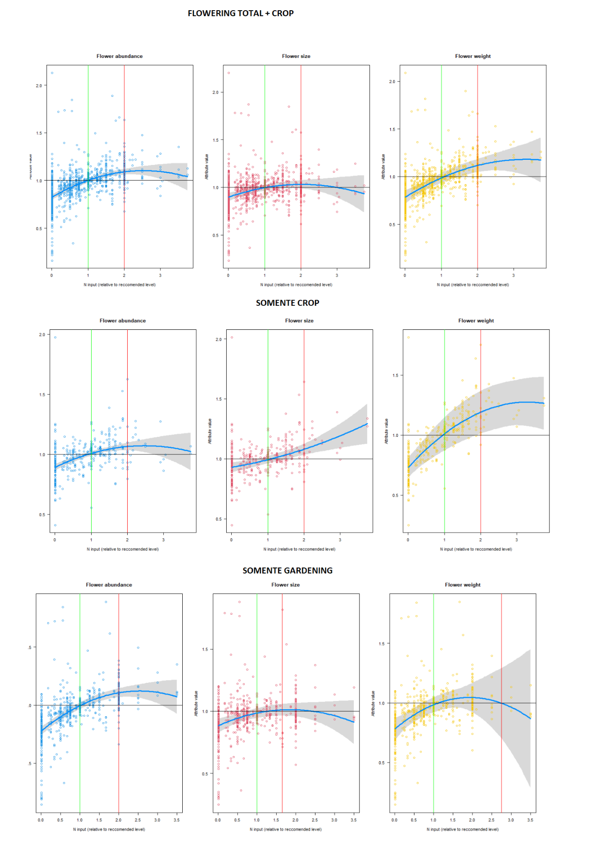

SUPLEMMENTAL MATERIAL

Table S1 - XXXXXXXXXXXXXXx

|  |  |  |
| --- | --- | --- |
| **Study** | **Country** | **Plant species** |
| Nejad and Shakib, 2013 | Iran | *Calendula officinalis* |
| Savalya and Vala, 2015 | Indian | *Solidago canadensis L* |
| Adesina et al., 2011 | Nigerian | *Cucumis sativos* |
| Ahmad et al., 2011 | Pakistan | *Tagetes patula* |
| Akter and Klecka, 2022 | Czech republic | *Sinapis alba* |
| Nawar; Salama; Hassan, 2020 | Egypt | *Helianthus Annus* |
| Alhasan et al., 2022 | Iraq | *Matricaria chamomilla* |
| Alvar-Beltran et al., 2020 | Italy | *Chenopodium quinoa* |
| Aminifard et al., 2010 | Iran | *Solanum melogena/Capsicum annuum* |
| Atasay et al., 2013 | Turkey | *Malus domestica* |
| Awais et al., 2013 | Pakistan | *Helianthus Annus* |
| Basal and Szabó, 2020 | Hungary | *Glycine max* |
| Bhasin et al., 2021 | USA | *Vaccinium corymbosum L* |
| Bi et al., 2010 | USA | *Tagetes patula* |
| Blazewicz-Wozniak; Kesik; Michowska, 2011 | Poland | *Allium ursinum* |
| Blazewicz-Wozniak; Kesik; Michowska, 2006 | Polinie | *Allium ursinum* |
| Brevedan; Egli; Leggett, 1978 | USA | *Glycine max* |
| Bryla et al., 2012 | USA | *Vaccinium corymbosum* |
| Bueckert et al., 2020 | USA | *Lens culinaris* |
| Campiglia; Radicetti; Mancinelli, 2017 | Italy | *Cannabis sativa L.* |
| Castaeda-Saucedo et al., 2023 | Mexico | *Agave amica* |
| Chau and Heinz, 2006 | USA | *Dendranthema grandiflora* |
| Chaudhary et al., 2020 | Indian | *Gaillardia pulchella* |
| Clark, 1997 | New Zealand | *Sandersonia aurantiaca* |
| Kurtz et al., 2013 | Brazil | *Allium cepa* |
| Diez; Osorio; Moreno, 2016 | Colombia | *V. planifolia* |
| Dunn; Shrestha; Goad, 2016 | USA | *Dianthus ‘Telstar* |
| Durner, 2017 | USA | *Fragaria ananassa* |
| Eidyan; Hadavi; Moalemi, 2014 | Iran | *Polianthes tuberosa* |
| Einizadeh and Shokouhian, 2018 | Iran | *Fragaria ananassa* |
| Elhindi et al., 2016 | Egypt | *Zinnia elegans* |
| El-Motaium et al., 2016 | Egypt | *Zebda mango* |
| Estaji; Souri; Omidbigi, 2011 | Iran | *Sylilbum Marianum* |
| Ferreira et al., 2019 | Brazil | *Prunus persica* |
| Kurtz et al., 2016 | Brazil | *Allium cepa* |
| Gadagi et al., 2004 | Indian | *Gaillardia pulchella* |
| Gandomi et al., 2021 | Iran | *Matricaria chamomilla* |
| Giannoulis et al., 2020 | Greece | *Origanum majorana* |
| Guirao et al., 2019 | Brazil | *Oryza sativa* |
| Higaki; Imamura; Paul, 1992 | Havai | *Anthurium andraeanum* |
| Swetha et al., 2018 | Indian | *Lilium auratum* |
| Jolliff; Seddih;Mcgahuey, 1993 | USA | *Limnanthes alba* |
| Jolliff et al.,1993 | USA | *Linmanthes flocosa* |
| Khalaj; Edrisi, 2012 | Iran | *Polianthes tuberosa* |
| Rajan et al., 2019 | Indian | *Chrysanthemum morifolium Ramat.* |
| Krol, 2011 | Polinie | *Calendula officinalis* |
| Kumar et al., 2017 | Indian | *Rosa damascena* |
| Gowthami et al., 2017 | Indian | *Crossandra infundibuluformis L* |
| Li et al., 2018 | USA | *Rhododendron sp* |
| Lin et al., 2019 | Taiwan | *Phaseolus vugaris* |
| Liu, WP; Muzolf-Panek, M; Kleiber, T | Poland | *Brassica campestris L* |
| Aminifard et al., 2010 | Iran | *Capsicum annuum* |
| Haque et al., 2011 | Bangladesh | *Lycopersicon esculentum* |
| Naik, 2014 | Indian | *Tagetes erecta* |
| Pandey et al., 2021 | Nepal | *Tagetes erecta* |
| Matysiak and Bielenin, 2005 | Poland | *Rhododendron sp* |
| Islam et al., 2019 | Bangladesh | *Spinacia oleracea* |
| Merida et al., 2017 | Brazil | *Costus productus* |
| Milic et al., 2012 | Serbia | *Malus domestica* |
| Aminifard et al., 2010 | Iran | *Solanum melogena* |
| Aminifard et al., 2018 | Iran | *Capsicum annuum* |
| Mou et al., 2012 | China | *Paphiopedilum armeniacum* |
| Mudau; Soundy; du Toit, 2005 | South Africa | *Ahtrixia phylicoides* |
| Aslam Khan et al., 2004 | Pakistan | *Zinnia elegans* |
| Awais et al., 2015 | Pakistan | *Helianthus Annus* |
| Polara et al., 2015 | Indian | *Tagetes erecta* |
| Nawaz et al., 2019 | Pakistan | *Gossypium hirsutum* |
| Nerd; Mesika; Mizrahi, 1993 | Israel | *Opuntia ficus-indica* |
| Nerd and Mizrahi, 1994 | Israel | *Opuntia ficus-indica* |
| Park and Faust, 2021 | USA | *Petunia ×hybrida* |
| Patil et al., 2020 | Indian | *Gladiolus grandiflorus* |
| Pearson and Jollif, 1986 | USA | *Limnanthes alba* |
| Phaikaew et al., 2002 | Thailand | *Paspalum atratum* |
| Pospisil et al., 2006 | Croatia | *Amaranthus spp* |
| Shusr, 1956 | Canadá | *Snapdragon* |
| Sendhilnathan and Manivannan, 2019 | Indian | *Polianthes tuberosa* |
| Gao et al., 2023 | China | *Capsicum annuum* |
| Kakon et al., 2016 | Bangladesh | *Phaseolus vugaris* |
| Sheoran et al., 2015 | Indian | *Polianthes tuberosa* |
| Abas et al., 2016 | Sudan | *Allium cepa* |
| Samoon et al., 2018 | Indian | *Calendula officinalis* |
| Shafiullah et al., 2018 | Pakistan | *Tagetes erecta* |
| Einizadeh et al., 2021 | Iran | *Strawberry cultivar 'Paros'* |
| Sharma, 1995 | Indian | *Oryza sativa* |
| Shehzad and Maqsood, 2015 | Pakistan | *Helianthus Annus* |
| Singh and Uma 1996 | Indian | *Polianthes tuberosa* |
| Singh; Sharma; Verma, 2013 | Turkey | *Helianthus Annus* |
| Souza et al., 2016 | Brazil | *Annona squamosa L* |
| Ye et al., 2019 | China | *Oryza sativa* |
| Vaudo et al., 2022 | USA | *Cucumis sativos* |
| Kumar et al., 2015 | Indian | *Calendula officinalis* |
| Yadav; Khokhar; Yadav, 2010 | Indian | *Fragaria ananassa* |
| Yoshida; Fujime; Chujo, 1992 | Japan | *Fragaria ananassa* |
| Lou et al., 2023 | China | *Saussurea nigrescens* |
| Yusuf et al., 2016 | Turkey | *Rosa damascena* |
| Kucukyumuk et al., 2013 | Turkey | *Lavandula × intermedia Emeric* |
| Zhao et al., 2022 | China | *Lespedeza davurica* |

Table S2 – XXXXXXXXXXx

|  |  |
| --- | --- |
| **Crop species name** | **Mean value for Pollination dependence** |
| *Cucumis sativos* | 0,56 |
| *Sinapis alba* | 0,7 |
| *Helianthus annuus L* | 0,54 |
| *Chenopodium quinoa* | 0,01 |
| *Solanum melogena* | 0,83 |
| *Pepsicum annumm* | 0,83 |
| *Passiflora edulis Sims* | 1 |
| *Vaccinium corymbosum L* | 0,53 |
| *Fragaria Sp* | 0,54 |
| *Prunus persica* | 0,37 |
| *Phaseolus vugaris* | 0,19 |
| *Lycopersicon esculentum* | 0,4 |
| *Gossypium hirsutum L.* | 0,2 |
| *Spinacia oleracea* | 0,01 |
| *Malus domestica* | 0,73 |
| *Capsicum annumm* | 0,48 |
| *Abelmoschus esculentus* | 0,14 |
| *Passiflora edulis* | 1 |
| *Allium cepa* | 0,93 |
| *Strawberry cultivar 'Paros'* | 0,54 |
| *D. longan* | 0,5 |
| *V. planifolia* | 0,01 |
| *Oriza sativa* | 0,01 |
| *Lens culinaris* | 0,01 |
| *Zebda mango* | 0,71 |
| *Soybean* | 0,19 |
| *Glycine max* | 0,19 |
| *Cucubita bepo* | 1 |
| *Capsicum annuum* | 0,48 |